Lab 2 - Implementing Decision Instructions in RISC V Assembly Language

Name: Romaisa Shazad  Myrah Hussain | Student ID: rb10107  mh10074

Task 1:

(for my help)
- Copy Code (remove the non assembly part)
- Ctrl shft d gives me run and debug - values stored in register
- Ctrl shft p -> venus assembly -> left column Program counter -> middle column is the hex value of the instruction. Alt we can also do ctrl shaft d -> venus options -> assembly
- Open calculator on laptop -> programmer options -> hex -> copy the hex value -> convert to binary -> copy the binary value somewhere
- Open the RISC V data green card -> code instruction format -> SB and then arrange bits according to each heading -> for unsigned extend MSB to make 32 bit
- We will have 2 imm values -> sort them
- left shift by 1 -> that’s the answer

Code:
LISTING 3:
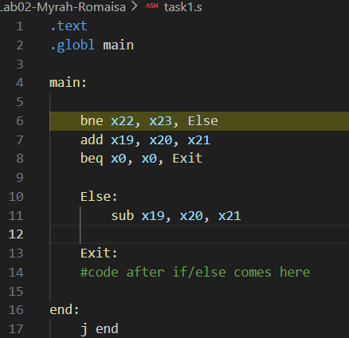

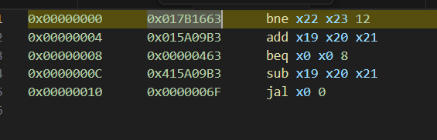

For BNE:
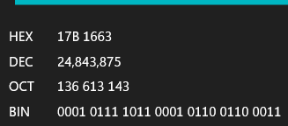

Results:
0000 0001 0111 1011 0001 0110 0110 0011 → binary
| imm[12] | imm[10:5] | rs2 | rs1 | funct3 | imm[4:1] | imm[11] | opcode |

imm[12 | 10:5] → 0000 000
rs2 → 10111
rs1 → 10110
Funct3 → 001
imm [4:1[11]] → 01100
op code → 110 0011

imm[12] → 0
imm[11]→ 0
imm[10:5]→ 000000
imm[4:1]→ 1100

final= 0000 0000 1100 (left shift 1 bit)

For BEQ:
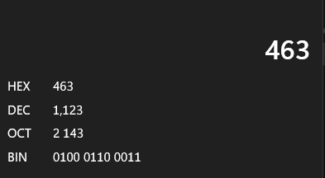
0000 0000 0000 0000 0000 0100 0110 0011 → Binary

imm[12 | 10:5] → 0000 000
rs2 → 00000
rs1 → 00000
Funct3 → 000
imm [4:1[11]] → 01000
op code → 110 0011

imm[12] → 0
imm[11] → 0
imm[10:5] → 000000
imm[4:1] → 0100
Final: 0000 0000 1000 (left shift 1 bit)

LISTING 4:
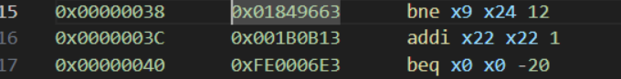

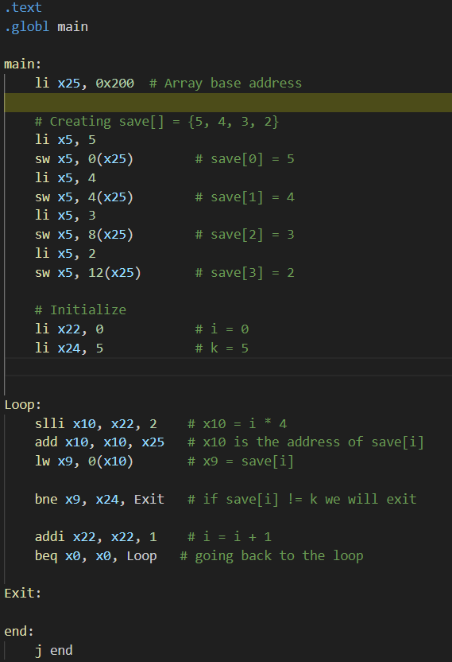
For BNE:
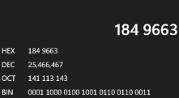

Binary → 0001 1000 0100 1001 0110 0110 0011

imm[12 | 10:5] → 0000 000
rs2 → 11000 (x24)
rs1 → 01001 (x9)
Funct3 → 001
imm [4:1[11]] → 01100
op code → 1100011

imm[12] → 0
imm[11] → 0
imm[10:5] → 000000
imm[4:1] → 0110
Final→ 0000 0000 1100 (left shift)

For BEQ:
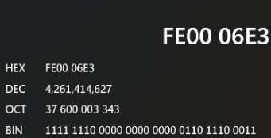
Binary → 1111 1110 0000 0000 0000 0110 1110 0011

imm[12 | 10:5] → 1111111
rs2 → 00000 (x0)
rs1 → 00000 (x0)
Funct3 → 000
imm [4:1[11]] → 01101
op code → 1100011

imm[12] → 1
imm[11] → 1
imm[10:5] → 111111
imm[4:1] → 0110
Final→ 1111111101100 (left shift)

Task 2:

Code:

Showing case 2:
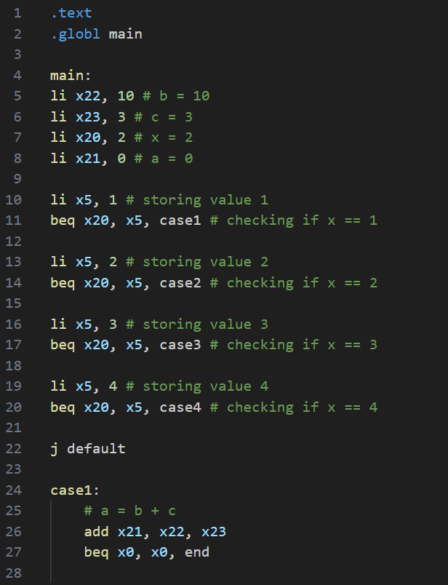
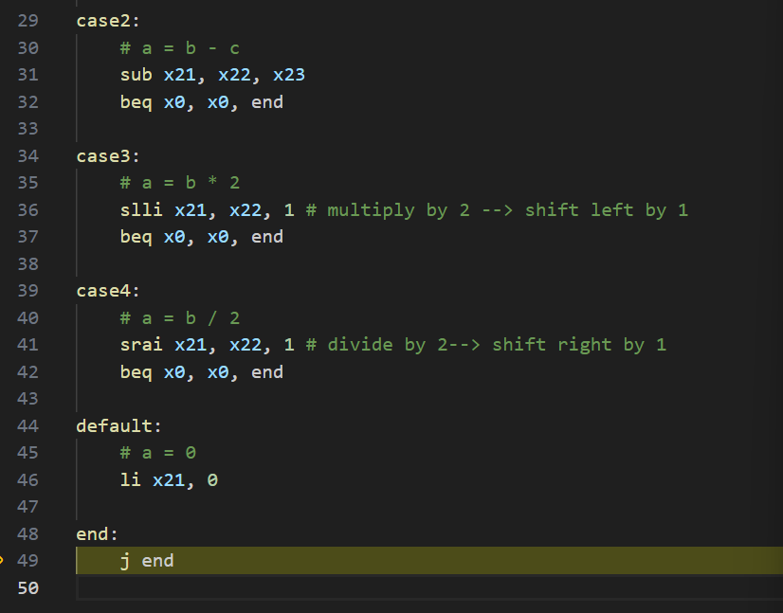

Results:
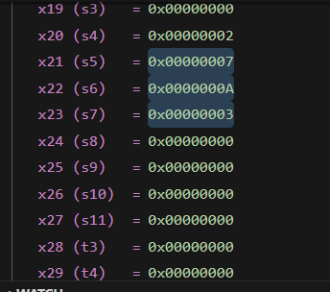

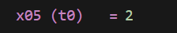
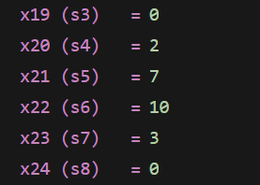

Case Default:
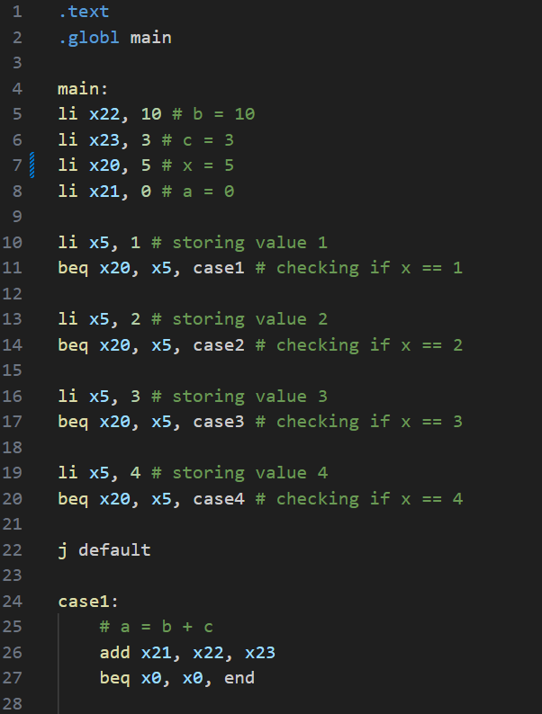

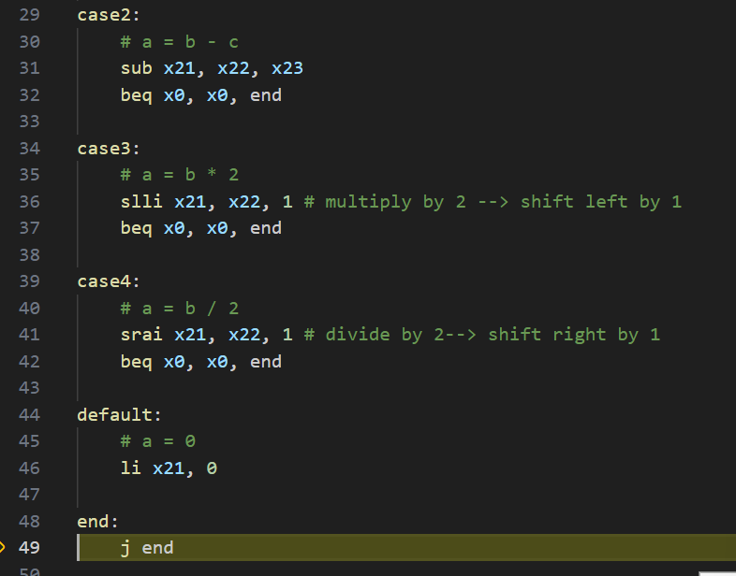

Results:
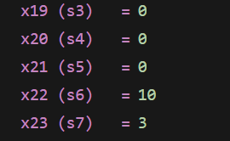

Case 3:
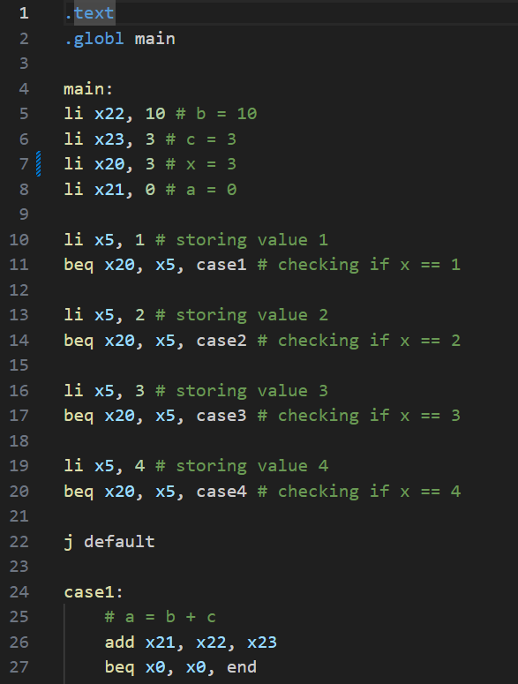
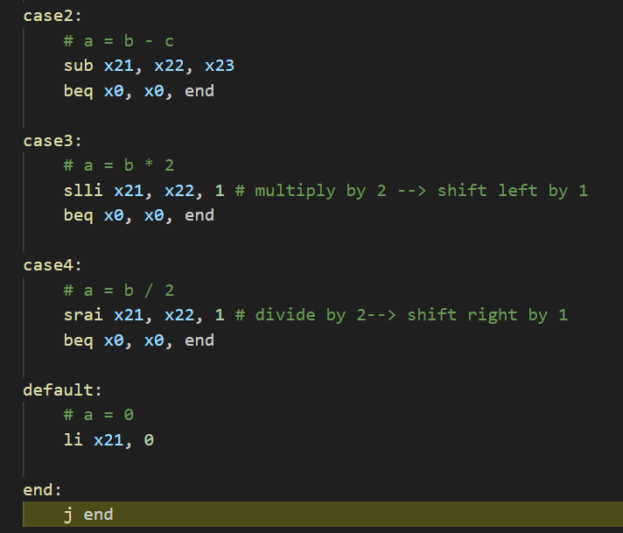

Results:
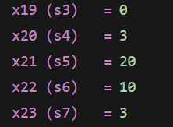

Case 1:
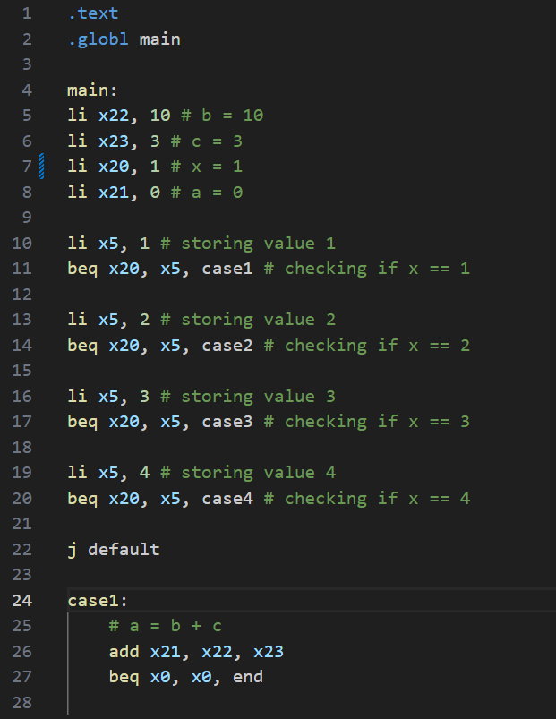

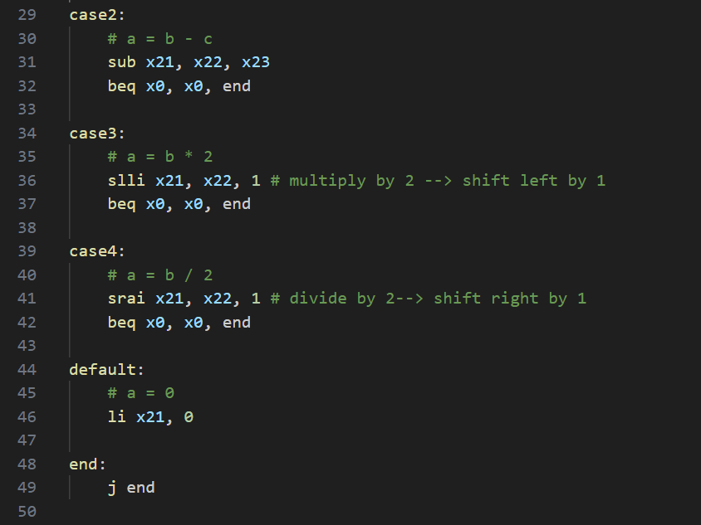

Results:
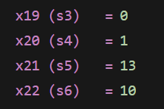

Case 4:
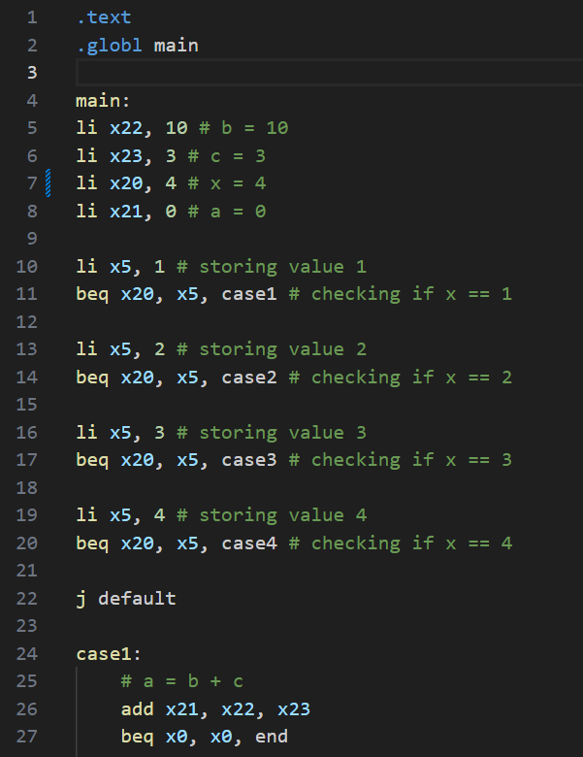
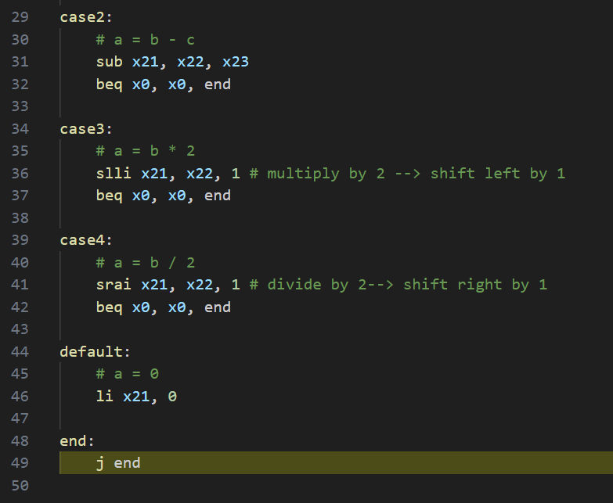

Results:
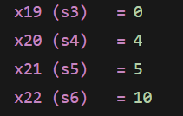

Task 3:

Code:
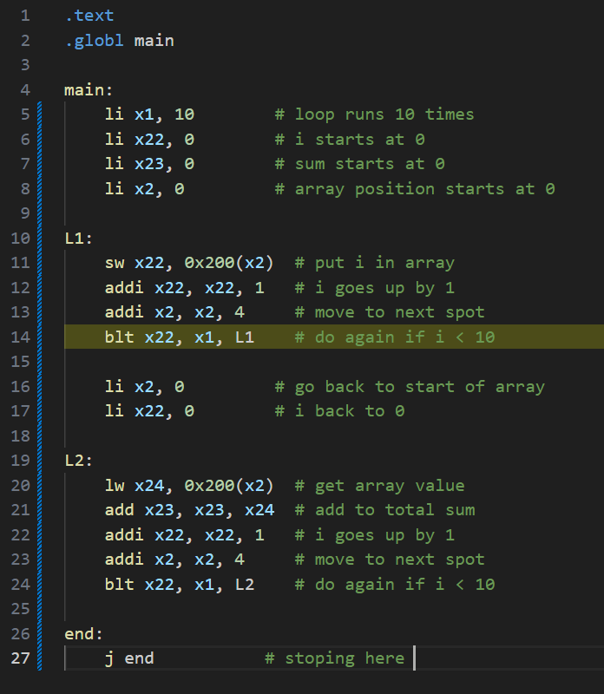

Results:
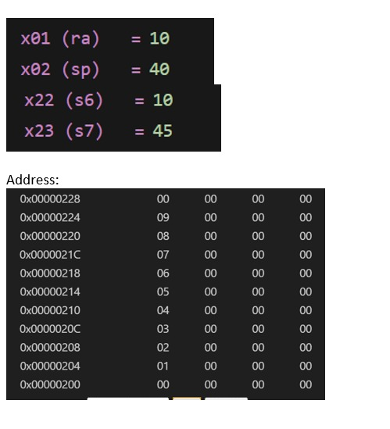

Task 4:

Code:
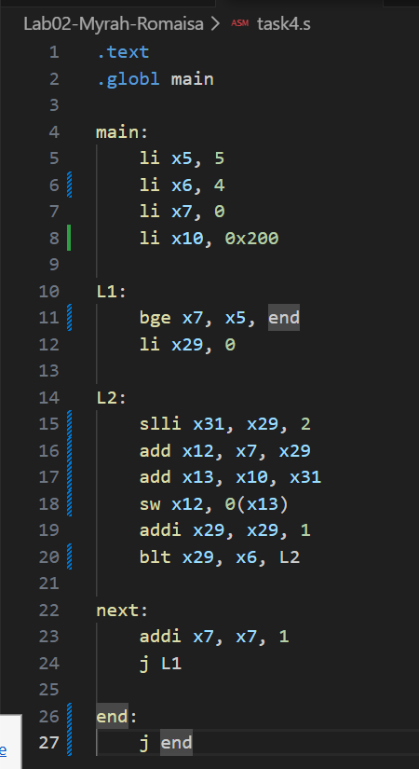

Results:
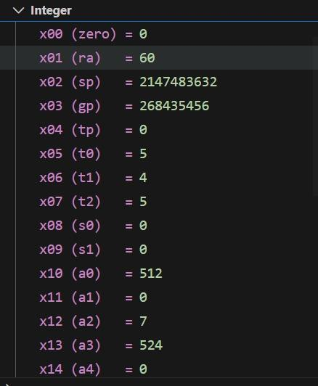
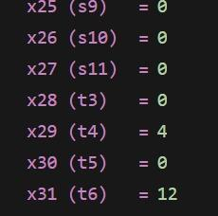
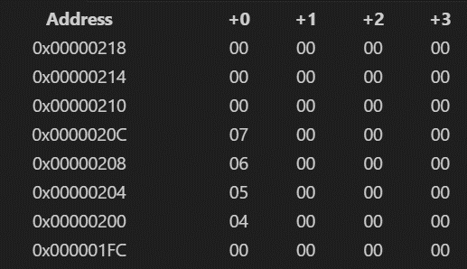

Assessment Rubric
Lab 2 - Implementing Decision Instructions in RISC V Assembly Language

Name | Student ID: | Section:

Points Distribution:

 | Task No. | LR 2 (Code) | LR 5 (Results)
In-Lab | Task 1 | - | /5
In-Lab | Task 2 | /10 | /10
In-Lab | Task 3 | /15 | /10
In-Lab | Task 4 | /20 | /10
Total Points: 100 |  | /45 | /35
CLO Mapped |  | CLO 2

Affective Domain Rubric |  | Points | CLO Mapped
AR7 | Report Submission & Git Upload | /10 & /10 | CLO 2

CLO | Total Points | Points Obtained
2 | 100
Total | 100

